Mobile Computing Assignment

Create Simple android application with login module which demonstrate use of various controls

Name: Ashutosh Mathore
Roll no.: 202010013

activity_main.xml:
<?xml version="1.0" encoding="utf-8"?>
<androidx.constraintlayout.widget.ConstraintLayout xmlns:android="http://schemas.android.com/apk/res/android"
xmlns:app="http://schemas.android.com/apk/res-auto"
xmlns:tools="http://schemas.android.com/tools"
android:layout_width="match_parent"
android:layout_height="match_parent"
tools:context=".MainActivity">
<Button
android:id="@+id/b1"
android:layout_width="wrap_content"
android:layout_height="wrap_content"
android:layout_marginTop="368dp"
android:text="Login"
app:layout_constraintEnd_toEndOf="parent"
app:layout_constraintHorizontal_bias="0.498"
app:layout_constraintStart_toStartOf="parent"
app:layout_constraintTop_toTopOf="parent" />
<EditText
android:id="@+id/uname"
android:layout_width="wrap_content"
android:layout_height="wrap_content"
android:layout_marginTop="148dp"
android:ems="10"
android:inputType="textPersonName"
app:layout_constraintEnd_toEndOf="parent"
app:layout_constraintHorizontal_bias="0.497"
app:layout_constraintStart_toStartOf="parent"
app:layout_constraintTop_toTopOf="parent" />
<EditText
android:id="@+id/pass"
android:layout_width="wrap_content"
android:layout_height="wrap_content"
android:layout_marginTop="252dp"
android:ems="10"
android:inputType="textPassword"
app:layout_constraintEnd_toEndOf="parent"
app:layout_constraintHorizontal_bias="0.497"
app:layout_constraintStart_toStartOf="parent"
app:layout_constraintTop_toTopOf="parent" />
<TextView
android:id="@+id/textView2"
android:layout_width="wrap_content"
android:layout_height="wrap_content"
android:layout_marginTop="128dp"
android:text="Username:"
app:layout_constraintEnd_toEndOf="parent"
app:layout_constraintHorizontal_bias="0.29"
app:layout_constraintStart_toStartOf="parent"
app:layout_constraintTop_toTopOf="parent" />
<TextView
android:id="@+id/textView3"
android:layout_width="wrap_content"
android:layout_height="wrap_content"
android:layout_marginTop="232dp"
android:text="Password:"
app:layout_constraintEnd_toEndOf="parent"
app:layout_constraintHorizontal_bias="0.292"
app:layout_constraintStart_toStartOf="parent"
app:layout_constraintTop_toTopOf="parent" />
</androidx.constraintlayout.widget.ConstraintLayout>

second_activity.xml:
<?xml version="1.0" encoding="utf-8"?>
<androidx.constraintlayout.widget.ConstraintLayout
xmlns:android="http://schemas.android.com/apk/res/android"
xmlns:app="http://schemas.android.com/apk/res-auto"
xmlns:tools="http://schemas.android.com/tools"
android:layout_width="match_parent"
android:layout_height="match_parent"
tools:context=".sample">
<TextView
android:id="@+id/textView"
android:layout_width="233dp"
android:layout_height="129dp"
android:layout_marginTop="116dp"
android:text="Login Successful"
android:textSize="30dp"
app:layout_constraintEnd_toEndOf="parent"
app:layout_constraintStart_toStartOf="parent"
app:layout_constraintTop_toTopOf="parent" />
</androidx.constraintlayout.widget.ConstraintLayout>

MainActivity.java:
package com.example.loginexample;
import androidx.appcompat.app.AppCompatActivity;
import android.content.Context;
import android.content.Intent;
import android.os.Bundle;
import android.view.View;
import android.widget.Button;
import android.widget.EditText;
import android.widget.Toast;
public class MainActivity extends AppCompatActivity {
Button b1;
EditText uname, pass;
@Override
protected void onCreate(Bundle savedInstanceState) {
super.onCreate(savedInstanceState);
setContentView(R.layout.activity_main);
b1 = (Button) findViewById(R.id.b1);
uname = (EditText) findViewById(R.id.uname);
pass = (EditText) findViewById(R.id.pass);
b1.setOnClickListener(new View.OnClickListener() {
@Override
public void onClick(View v) {
String username = uname.getText().toString();
String password = pass.getText().toString();
if ((username).equals("admin") && password.equals("123"))
{
Intent intent = new Intent (MainActivity.this,sample.class);
startActivity(intent);
}
else
{
Toast toast = Toast.makeText(MainActivity.this, "Error: Wrong Username or Password!" , Toast.LENGTH_LONG);
toast.show();
}
}
});
}
}

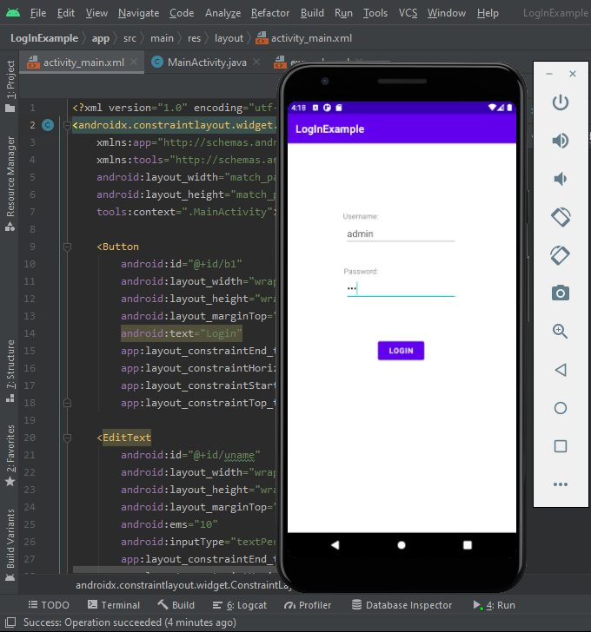
Output:
